|  |  |  |  |  |  |  |  |  |
| --- | --- | --- | --- | --- | --- | --- | --- | --- |
| LSL06.1 | 19-OCT-2018 | 09:00:00 | Purchase Order Lines Changes Expose | Expose purchase order lines changes to PBSA POS | Sayuru | Active | Fail | testing is in progress in Lanka Sathosa Test instance |

| Sequence # | Date | Time | Test Name | Description | Tester | Test Status | Pass/Fail | Notes |
| --- | --- | --- | --- | --- | --- | --- | --- | --- |

Actual initiated programme code integration

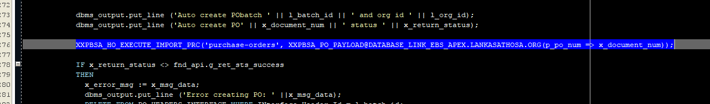

Manual REST client code execution

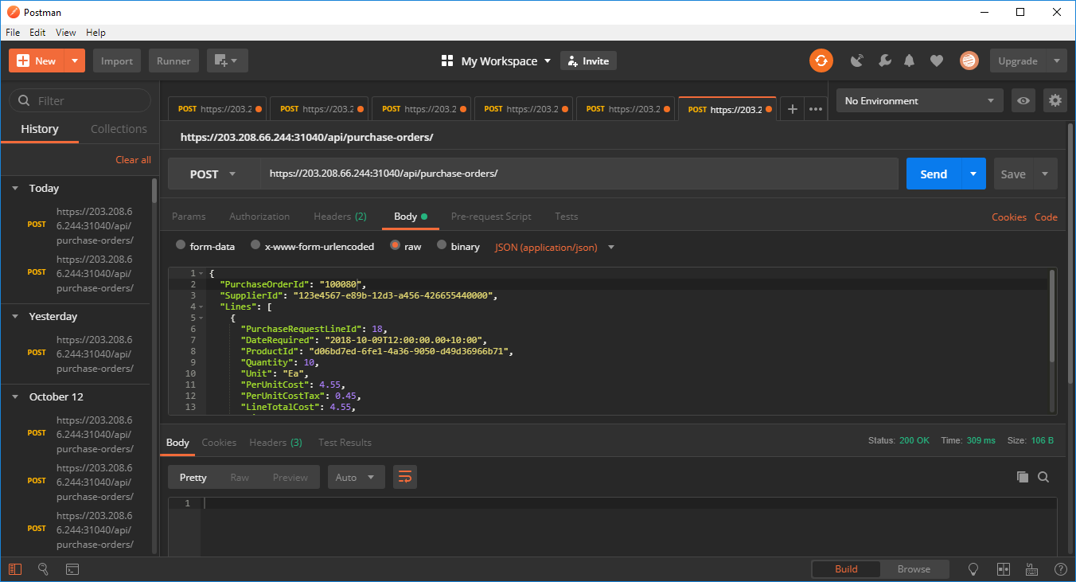

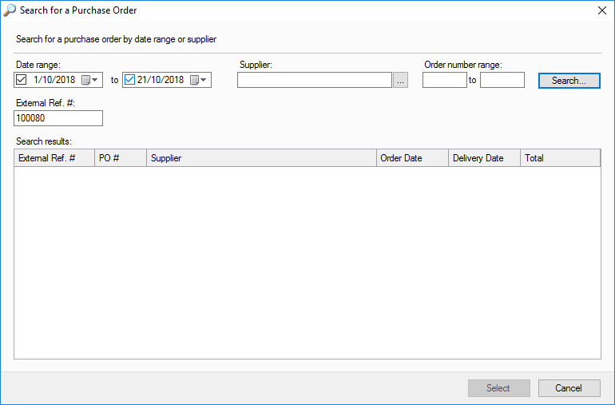

Figure 1

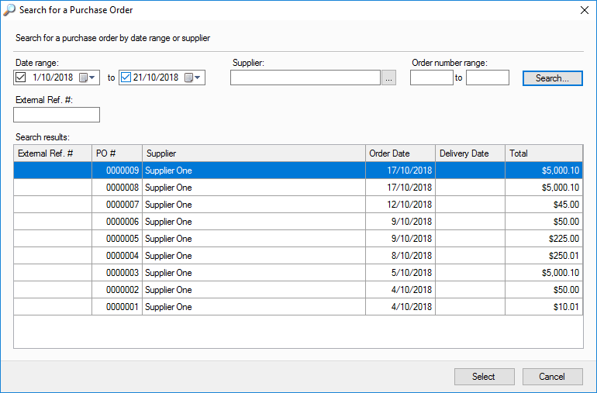

Figure 2

| Scenario Step | Test Step | Role | Action or Path | Expected Results | Actual Results | Expected Cycle Time | Actual Cycle Time | Status |
| --- | --- | --- | --- | --- | --- | --- | --- | --- |
| LSL12 | Get Authentication, set parameter and invoke GET /purchase-requests | Test User | Exposed Purchase Requests from Oracle Database | Web service response complete normally with no exceptions | Successful Operation | > 2 min | 1.5 Min. | Active  .Smoke Test Pass  .Integration Test Pass  .Regression Test Pending |
| LSL12.1 | Get Authentication, set parameter and invoke GET /purchase-requests | Test User | Exposed Purchase Requests from PBSA POS | Web service response complete normally with no exceptions and update PBSA POS External Reference Number | Successful Operation | > 2 min | 1.5 Min. | Active  .Smoke Test Fail  .Integration Test Initiated  .Regression Test Pending  Figure 1/Figure |